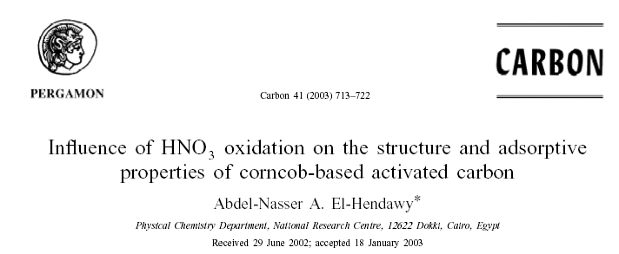

Carbon 41 (2003) 713–722
I nfluence of HNO oxidation on the structure and adsorptive 3
properties of corncob-based activated carbon
* Abdel-Nasser A. El-Hendawy

